Queer School of Live Art: Cohort Pack

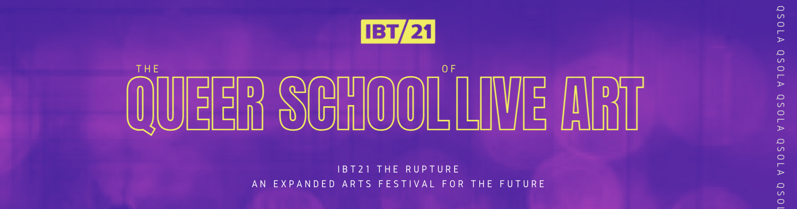

Outlined in this document:

- Introduction

- Artists’ Opportunity

- How to apply

- Selection Criteria

Introduction

The Queer School of Live Art is a direct response to a call

We’re creating the school we wish we had

Come with us.

We are seeking 6-10 artists to form the very first cohort through this fully-funded programme.

The Queer School of Live Art (QSoLA) focuses on the incredible work of LGBTQAI+ live artists. Together, we will explore In Between Time’s rich archive, following where it leads us, out into other programmes and artists’ works. QSoLA has been created to support LGBTQAI+ artists from Bristol who want to be introduced to, learn about and practice live art.

Over six weeks, the selected cohort will experience a fully-funded programme of workshops and the opportunity to meet other artists, experience live performances and develop their practice as part of IBT21 The Rupture - an expanded festival for the future.

QSoLA has been developed and produced by In Between Time’s Associate Curator Beth Palmer and In Between Time

In Between Time
In Between Time is a leading international live art producing organisation in the UK, globally recognised for its pioneering work. Known as producers of extraordinary art works, and the biennial In Between Time Festivals, In Between Time sits at the heart of a network of live art organisations at the forefront of innovative contemporary arts practice. We encourage artists and audiences to think, to dream, to do things they have not yet imagined.

In Between Time premiere, commission and produce radical artistic voices in our home city of Bristol and across the world. Working in partnership we empower local people to work with international art makers through co-authorship and collaboration. We are committed to seeking out unheard voices, challenging preconceptions and institutionalised practices, to ensure the world’s most urgent stories get heard.
A Bristol-based arts charity since 2001, we nurture an internationally significant live art ecosystem for artists, audiences and participants. We have been delivering provocative and memorable events at micro or large--scale across the sites and spaces, nooks and crannies of this city for 20 years.
What is live art?
Live Art is not a singular form of art but an umbrella term for intrinsically live practices that are rooted in a diversity of disciplines and discourses involving the body, space and time. Live Art is a cultural strategy to make space for experimental processes, experiential practices, and the bodies and identities that might otherwise be excluded from traditional contexts.

Artists Opportunity

We are looking for:
Bristol-based LGBTQIA+ artists
Aged 18+
Artists who are interested in learning about and practising live art

Queer School of Live Art offers 6 x 45 minute sessions over 6 weeks culminating in a live performance cabaret event as part of IBT’s The Rupture - an expanded festival for the future.

October
Introduction session by Beth Palmer and Marcin Gawin
November
Four one-hour workshops with leading queer live artists
Two-hour session to develop your performance

December
Performance in live cabaret as part of IBT’s The Rupture expanded festival for the future programme

The successful applicants will attend the introductory session and the five workshop sessions. You must be available for the full six sessions (dates tbc) and to perform in December 2021, as illustrated in the below table. Dates are subject to change.

Introductory session | 15/10/21 | Arrive PM
Workshop 1 | November tbc | 2-hour workshop
Workshop 2 | November tbc | 2-hour workshop
Workshop 3 | November tbc | 2-hour workshop
Workshop 4 | November tbc | 2-hour workshop
Performance development | November tbc | 2-hour session
Live Art Cabaret | December tbc | Two full days

How to apply

Please fill in this form to apply for a place at the Queer School of Live Art. We are happy to accept your responses to the application in any format which suits you.

Please include the information outlined below to help us get to know you. The QSoLA programme is for those that do not yet have an established live art practice and the curriculum will reflect this, by sharing this information now you will help us shape what we will be learning together.

- Who you are
- Why you think this programme would benefit your practice
- What your interest in live art is

Please ensure video and applications are up to two minutes.

If you have any questions or wish to discuss QSoLA with the In Between Time team please email bethany@inbetweentime.co.uk to arrange a chat.

Application deadline: 19th September 2021
Applicants will be informed by 27th of September 2021

